|  |
| --- |
| NAME: Ayush Vinod Upadhyay  ROLL NO: I025  SAP ID: 60003220131  BRANCH: Information Technology  BATCH: 1 |

1. WAOOP to count the no. of objects created of a class using constructors.

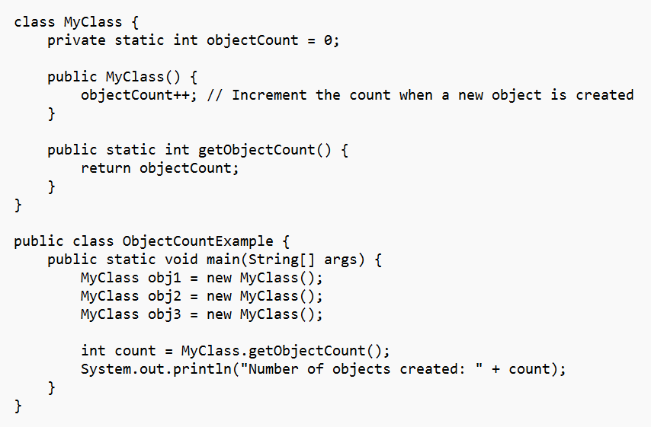

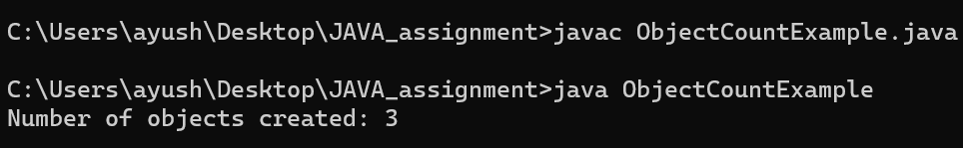

2. WAP to display area of square and rectangle using the concept of overloaded constructor (use parameterized, non-parameterized and copy constructor).

